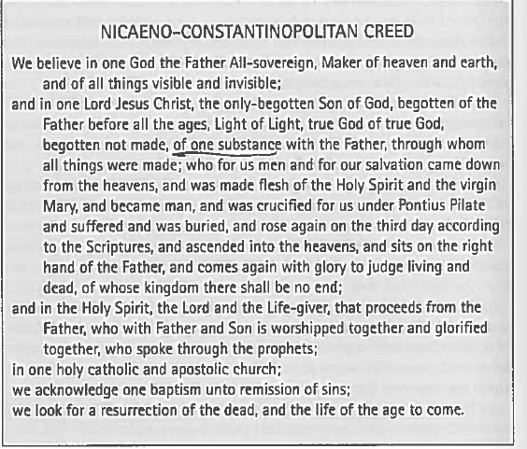

Source: Everett Ferguson, Church History, Vol One. From Christ to Pre-Reformation (2005), pg. 210

